Lakehouse Fundamentals

What is the databricks lakehouse platform ?

1/ Describe the databricks lakehouse platform

* DataBricks is Data and IA platform
* Pioneer of the data lakehouse
* Gartner recognized leader in both
  + Database Management sustems
  + Data Science and machine learning plafroms
* Creator of highly successful OSS data
  + Delta lake
  + Apache spark
  + MLFlow
* Global adoption
  + Retail
  + Finance ..
* Ingest and explore data + machine learning
* Assosicate datascience and machne
* Web interface :
* Single unified system
* Commit to open source project
* Acces to open source project through platgorm
* 450 partner to gel use platforms
* Allow data science team to collaborate
* Why
  + Big Data and AI challenges
    - 83% of CEO
    - 85 of big
  + Big data high to manage (volume, wide colums
  + Manage type data
  + Kee track of data
  + Many tools , doesn’t work together
  + Avoid multiple stack set up
  + Easy data security and governance (on the same platform
  + 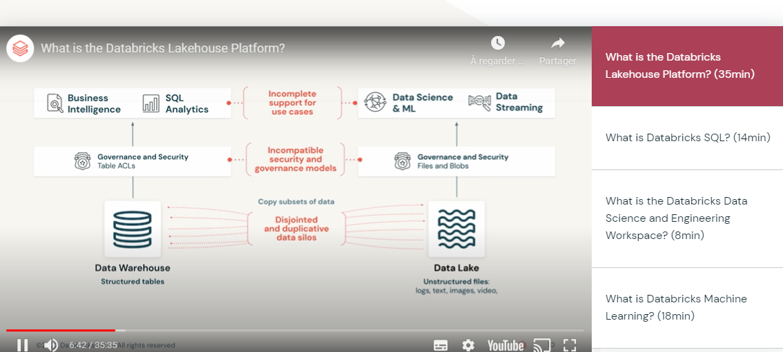
* Lakehouse paradigm
  + Combined data wahouse and data lake
    - Data warehouse

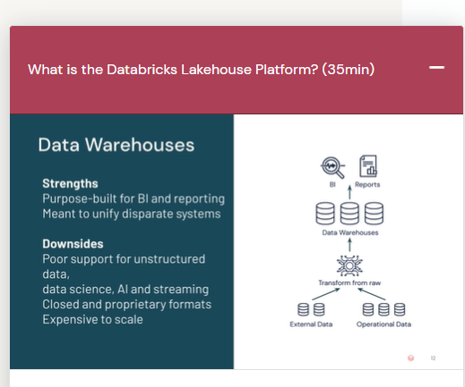

* Data lake (sotre cheap and efficiently)
  + Any nature, any format
  + Decouple data warehouse design, not need to structure and clean the data
  + Take data from datalake => data warehouse > BI
  + Volume can grow quickly
  + Accesing multiple system
  + Most complete and actual data for data science
  + Data schema help to aggregate time to construct
* Lake house
  + Delta lake

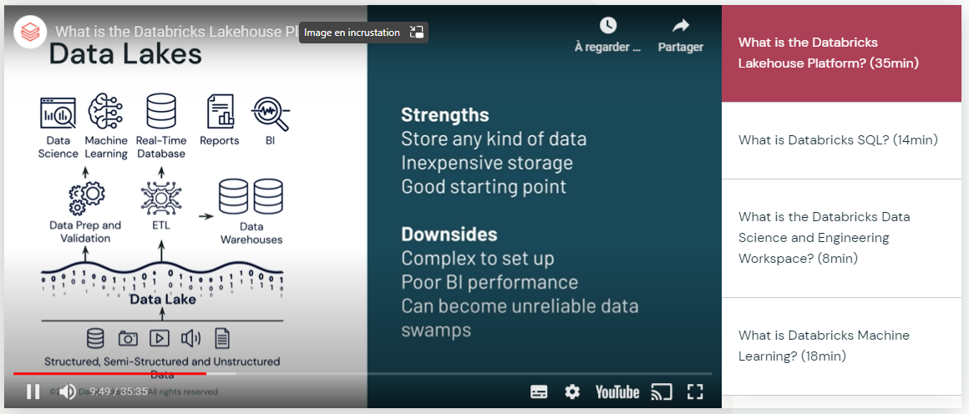

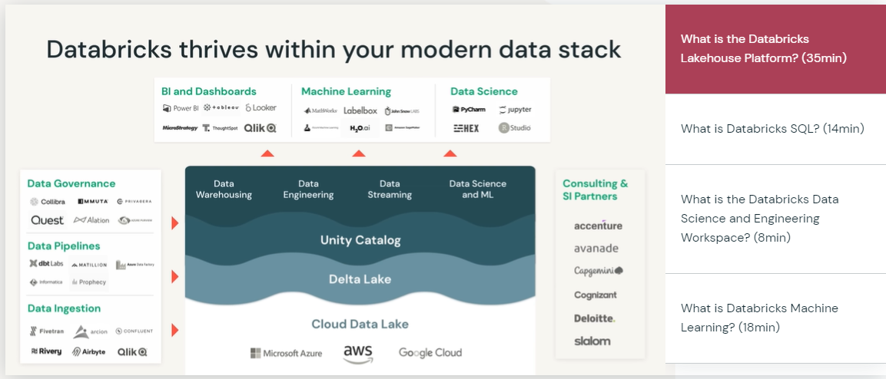

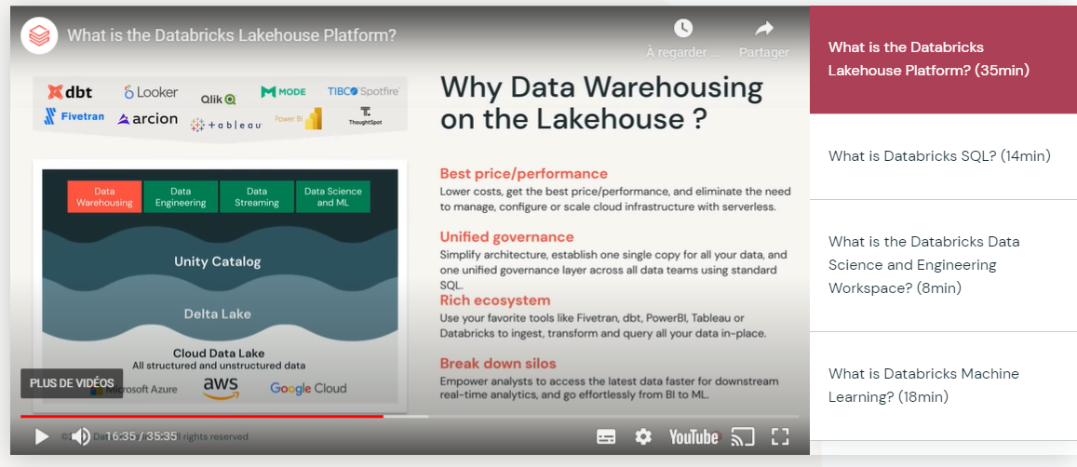

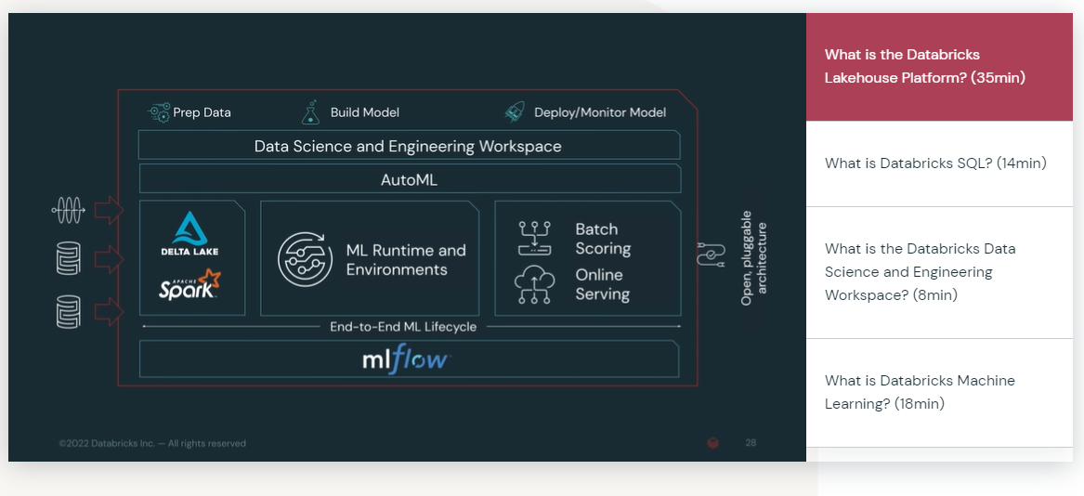

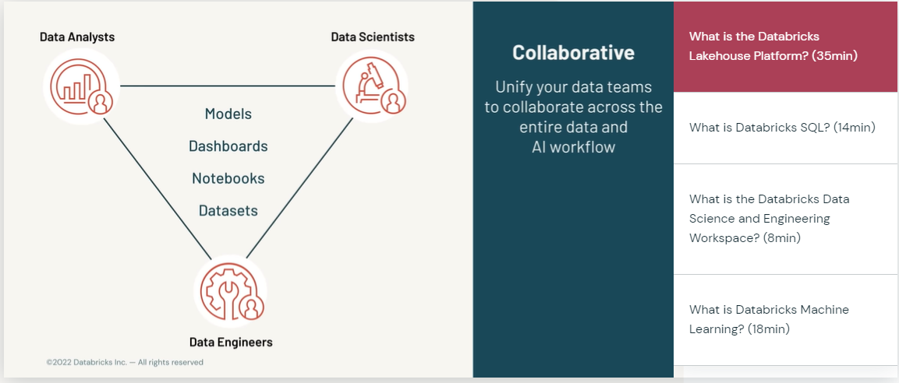

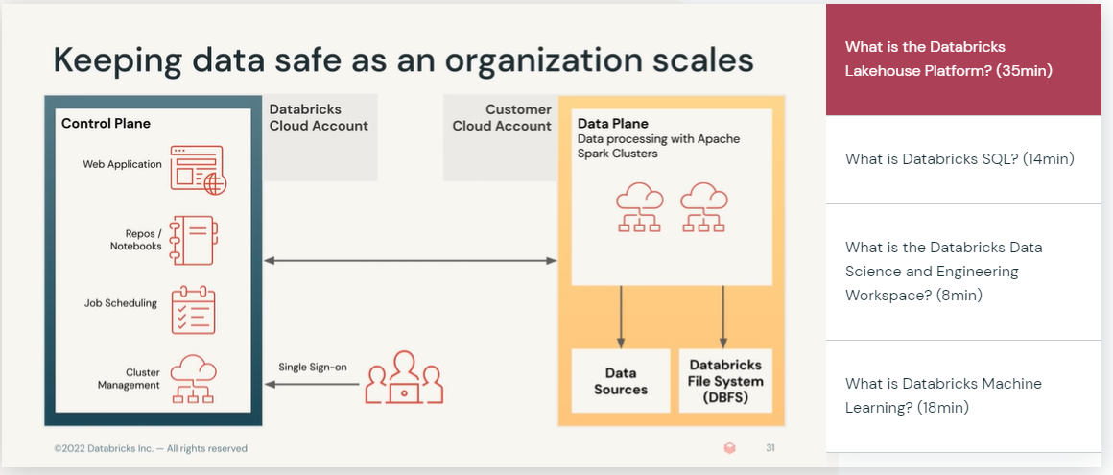

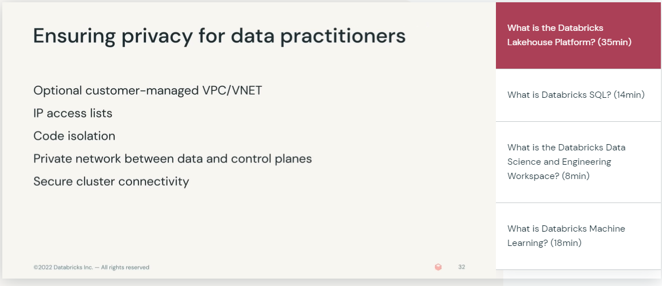

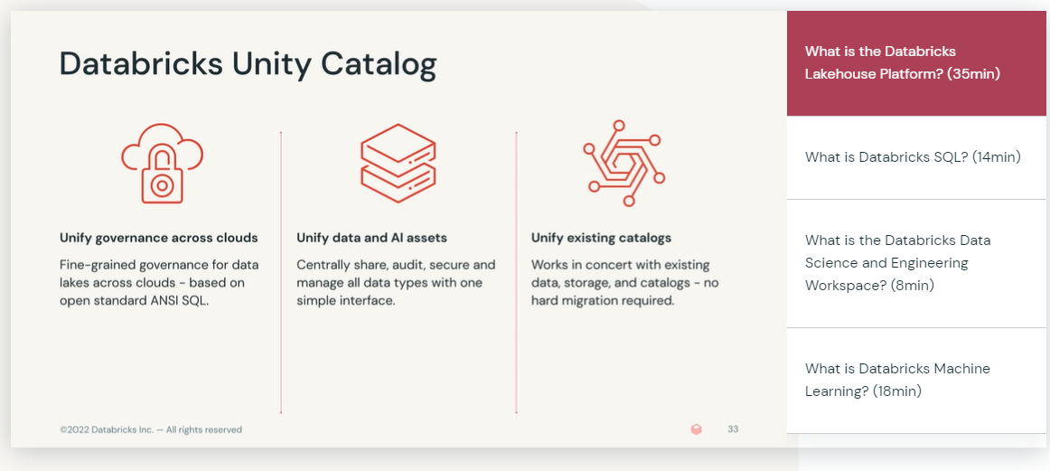

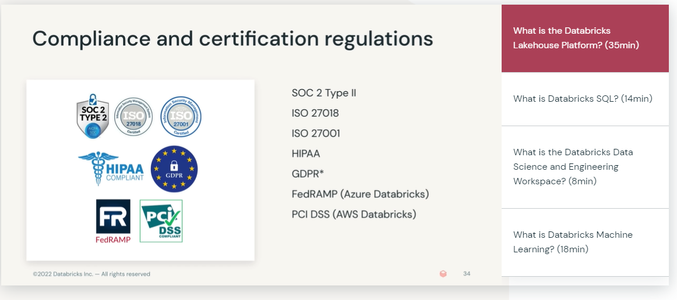

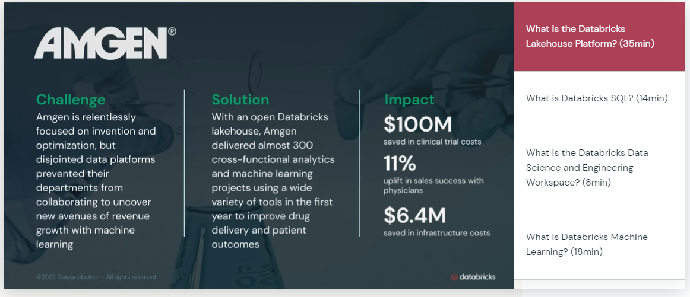

2: explain the origin of the lakehouse data management paradimg

3. outiline fundamental challenfes related to managing and using data

4. describe security features of the databricks lakehouse platform

5 Gie example of orgainsation that benefited from using the databricks lakehouse platform

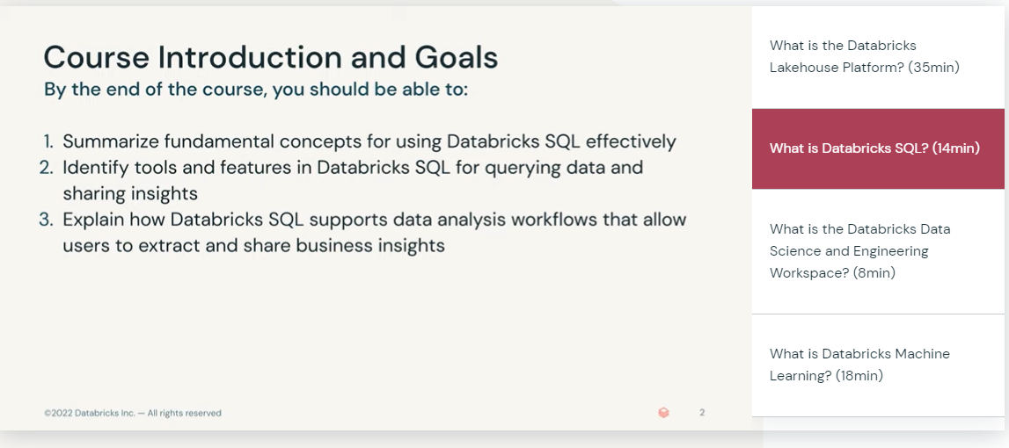

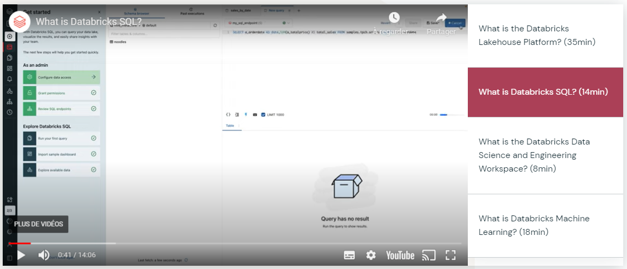

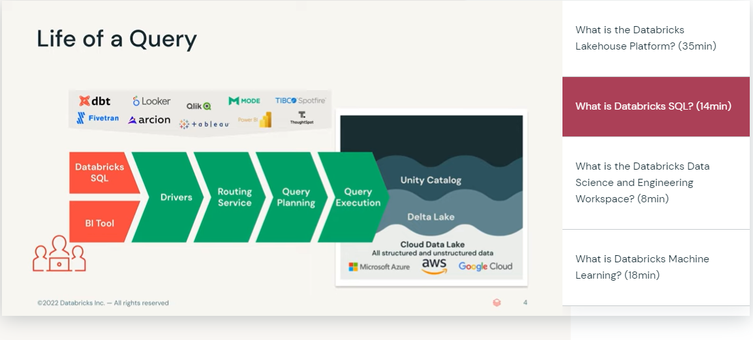

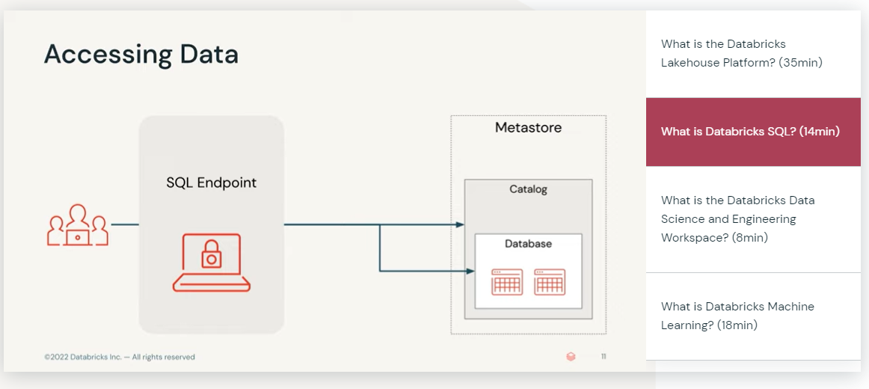

* + - * + SQL endpoint(is computed resource to compute the querry :

Serverless, manage by databrics

Cloud

* + - * + Catalog (database : collection of table )

Catalog = database name to acces

* + - * + 3 workspace

Machine learning

Data engineer data science

sQL

* + - * + Create :

query

Table

Dashboard

Alert

Endpoints

* + - * + SQL editor (sql quzry
        + Query panel (create, edtit ,
        + Alert monitor data , threshold
        + Data catalog
        + SQL endpoints

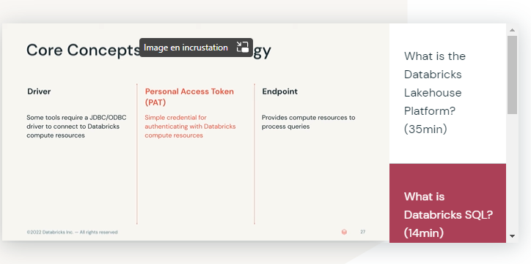

* + - Data engineer data science
      * Notebooks
      * Workflow
      * Experiment

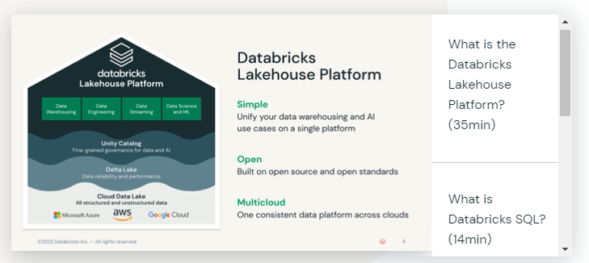

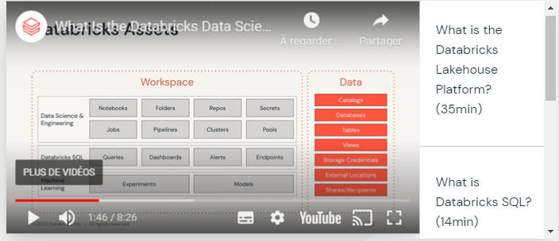

* + - * Note

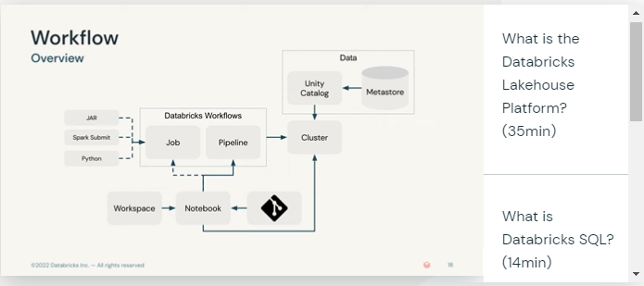

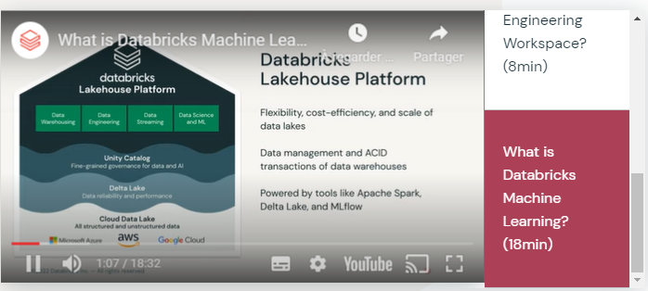

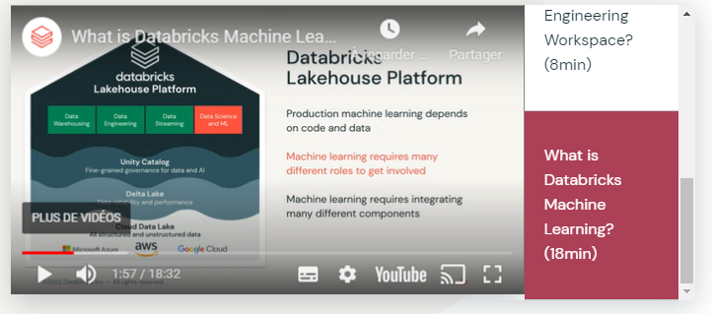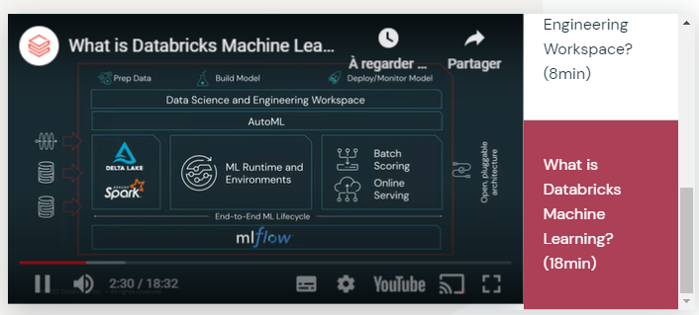

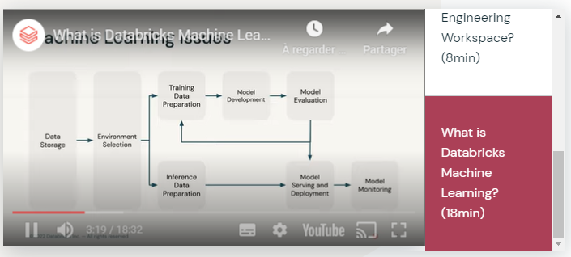

* + - * Data quality : data native delta lake
      * Compute resources : autoscaling resource
      * Feature development (set correct feature value): feature store , organize feature un clean way
      * Model development (caostly to be organize): glass box model, series models to explore with MLflow
      * Governance and security (artifact): contral by unitil catalog
      * Machine learning operation : can store model , and serve model through mlflow
    - Solution
      * Runtime ML (set environment for datascience , installed lib etc

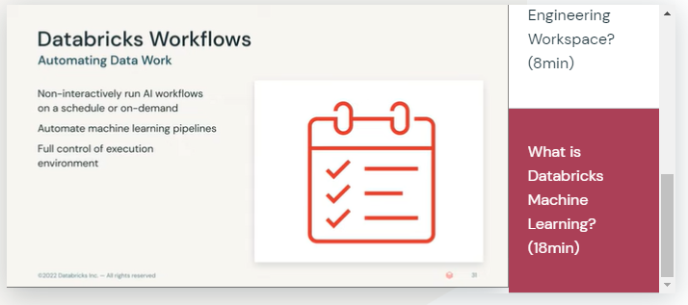

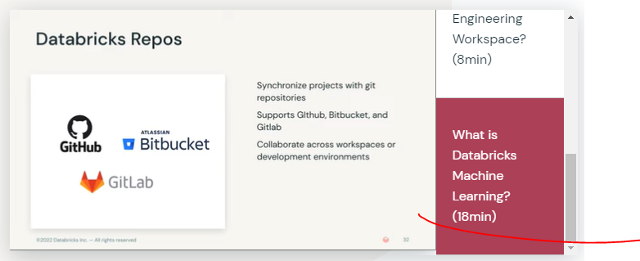

* + AutoML: builds models
    - Can use automl code to
    - Cluster , type problem , compare models